**M.S.SANJAY**

**15BCE0517**

**Microprocessor and Interfacing**

**Lab Experiment 6**

**1). Write an ALP to sort the array elements in ascending and descending order?**

**Code: Ascending Order**

.model small

.stack 64

.data

arr db 99h,12h,56h,45h,36h

.code

start:mov ax,@data

mov ds,ax

mov ch,04h

up2:mov cl,04h

lea si,arr

up1:mov al,[si]

mov bl,[si+1]

cmp al,bl

jc down

mov dl,[si+1]

xchg [si],dl

mov [si+1],dl

down:inc si

dec cl

jnz up1

dec ch

jnz up2

mov ah,4ch

int 21h

end start

end

**Output:**

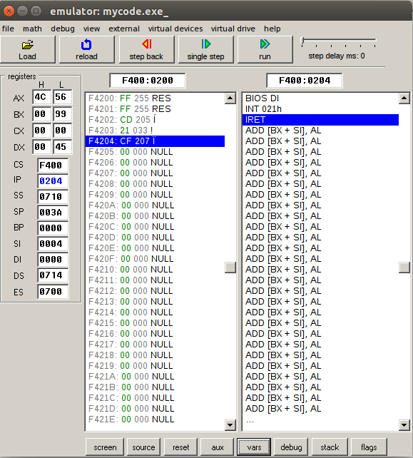

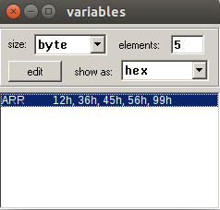

**Code for Descending Order:**

.model small

.stack 64

.data

arr db 99h,12h,56h,45h,36h

.code

start:mov ax,@data

mov ds,ax

mov ch,04h

up2:mov cl,04h

lea si,arr

up1:mov al,[si]mov bl,[si+1]

cmp al,bl

jnc down

mov dl,[si+1]

xchg [si],dl

mov [si+1],dl

down:inc si

dec cl

jnz up1

dec ch

jnz up2

mov ah,4ch

int 21h

end start

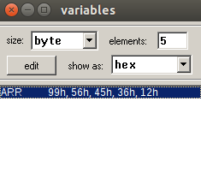end

**output:**

